SeniorsFirst

A certain school gives privileges to its students according to their academic class. One privilege is at the cashiers in the dining room, in which students join the queues, but check out according to the priority of their academic class, namely, Seniors first, then Juniors, then Sophomores, and finally Freshmen. If there are two or more Seniors (for example) in the queue, the one who arrived earliest gets served first.
Se | Ju | So | Fr | Fr
Ju | Ju | Fr
Se | Se | Ju | So | Ju | Fr
Se | Ju | Ju | Fr

ArrayList of PriorityQueues of different Customers

For each of the four academic classes, we will count the number who checked out, the average wait time, and the longest wait time. The statistics will be printed to the screen and to the file, while the priority queues will be printed to file only.

Hints on the Assignment
SeniorsFirst.java is a modification of CustomersInQueue.java in which the Array of Customers and one Queue<Customer> are replaced with an ArrayList of PriorityQueue of Customer.

You will need to modify the previous Customer class so that it works in a priority queue. How?
- You will need a new field in Customer to store its academic class. (Alternatively, some students make 4 subclasses to model each kind of Customer.)
- Since here we will have the chance of more customers per minute you will need an extra field, let’s call it position, so that the minute of arrival plus position will uniquely identify a customer.
- Since the service area now does not exist, means you will have to have a variable, a flag as a private field that states if a customer is at the front of the queue or not. This means that if a customer is in front of the queue he has highest priority of all so he can’t be bumped back.
- The Customer class will have now a 2-arg constructor which records the time of arrival and position. Both the time spent at the cashier and the academic class are set at random.
- You will have to figure out to store the academic class so that the seniors have the highest priority, then Juniors, then Sophomores, and lastly Freshmen. Reminder: if a person is in front of a queue he has the highest priority.
- The compareTo method in Customer compares this customer to another and returns the correct signal. Remember that in priority queues, the highest priority returns the lowest number. In this lab, the priority is Seniors first, then Juniors, then Sophomores, and finally Freshmen. If there are two or more Seniors (for example) in the queue, the one who arrived earliest should get served first. Also if a person is at the front of the queue has the highest priority of all.
- The toString method needs to return the minute, position, class and time spent at the cashier, for example, a sophomore with lots to check out might show as 0-1-So:7.

It will be convenient to store the statistics in three parallel arrays of int.
String[] classes = new String[]{"Senior", "Junior", "Sophomor", "Freshman"};
int[] served = new int[]{0,0,0,0};
int[] longestWait = new int[]{0,0,0,0};
int[] totoalWait = new int[]{0,0,0,0};

Sample Run
Printed to the screen:
Seniors First Simulation!
How many cashiers? 4
How long, in minutes, should the simulation run? 60
Customer Total Longest Average Wait
Senior 23 10 4.434782608695652
Junior 18 40 7.666666666666667
Sophomor 14 28 13.285714285714286
Freshman 1 2 2.0

The priority queues are printed to a file. Also the stats are printed to a file. When a customer leaves you are printing to a file. Here is a sample of a file created for 2 cashiers and 6 minutes:
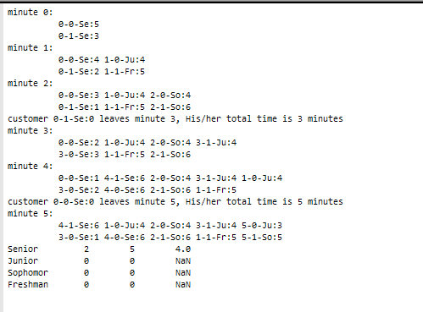

If you look at every individual queue, the person in front tends to be what class? How do the rest of the queue feel likeOnce a customer leaves a queue who is in front in the same queue? Does your queue behave as it was intended?

Extension
Make a class MyPriorityQueue which implements a priority queue. It's your choice as to how you will implement the priority queue.

Test your resource class with SeniorsFirst as the driver. You should not have to make any other changes in SeniorsFirst.

